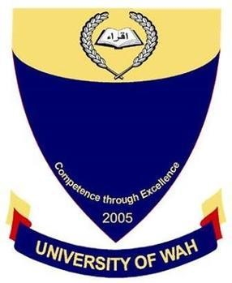
Object-Oriented-Programming Lab_CS-112L
UW-24-CS-BS-101
Registration NO:
Muhammad Talha_CS.2ndB
Lab Task # 03
UNIVERSITY OF WAH(UOW)

DEPARTMENT OF COMPUTER
SCIENCE

COURSE:

SUBMITTED TO:

Mr. Hassan Shafaqat
SUBMITTED BY:

Program # 01

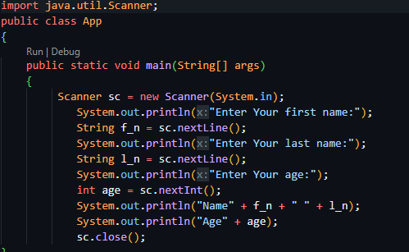

Output

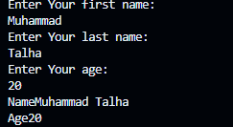
Program # 02
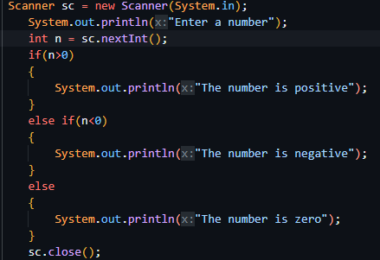

Output

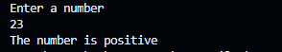

Program # 03

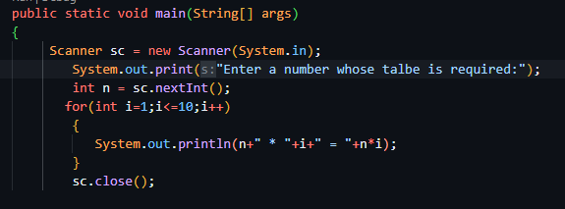

Output

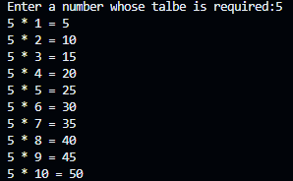

Program # 04

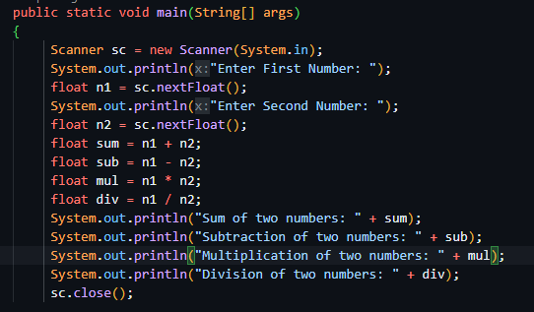

Output

